**Agglomerative hierarchical cluster tree(Terrance Kuo):**

A hierarchical clustering group has data over a variety of scales which it represents by creating a cluster tree or dendrogram. The tree is not a single set of clusters, but rather a multilevel hierarchy, where clusters at one level are joined as clusters at the next level. Since I am trying to do agglomerative clustering, I am using matlab to process my data. Some difficulties have been prevalent in trying to do this, as I do not have as much experience with matlab. Additionally the dataset is enormous as it is a 144582 by 21 table. Trying to represent this is difficult and I will need more information on what segments to process. The current methods to represent it in a 3d environment also cannot process all 144582 points without giving an error from insufficient memory so right now I have to put them through in segments. However I have been able to get visual data and split them into 7 clusters like with the pictures below.

Data plot of segment

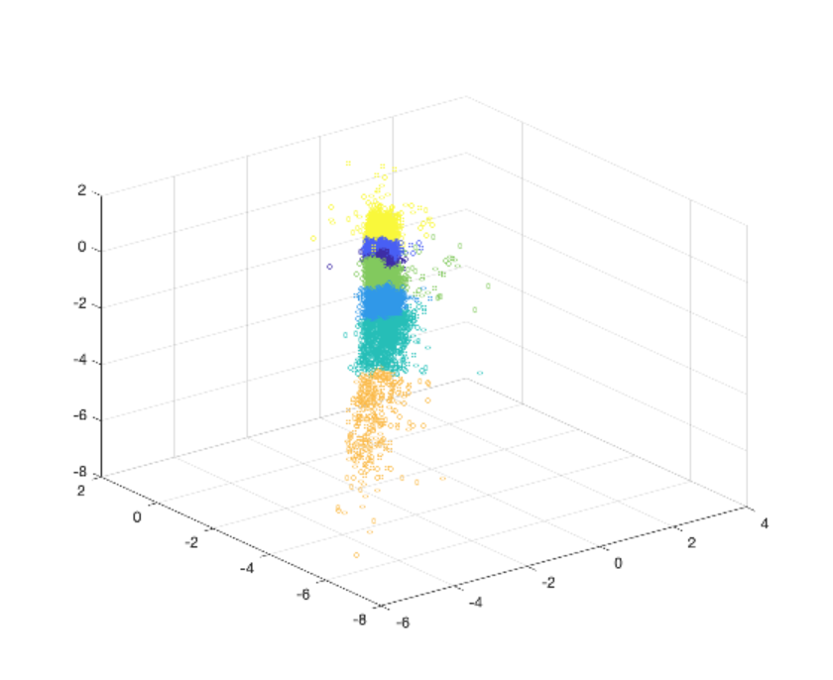

Dendrogram of segment

